R-Booking

Requirements Specification and Analysis

Version 1.0

19.10.2018

Mert Pekduzgun

Abdulwahab A. Sani

Alper Cevik Burak Sonmez

Prepared for SE301 Software Engineering

!

**Table of Contents**

1. Introduction 3

1.1.Purpose of the System 3

1.2.Scope of the System 3

1.3.Objectives and Success Criteria of the Project 4

1.4.Definitions, Acronyms, and Abbreviations 4

1.5.Overview 5

2. Current System 6

3. Proposed System 6

3.1.Overview 7

3.2.Functional Requirements 8

3.3.Nonfunctional Requirements 9

Usability- We made our system very usable and to measure this, making a reservation only takes five clicks. And this is the main functionality of our system. So just about anyone with basic knowledge of technology can use our system 9

Reliability- Our system is expected to run 100% of the time so that our users can be able to reserve at any time 9

Performance- System performance needs to be optimal, this includes search results times, loading restaurant pages etc.. So our users wont need to wait too long for system to load. We also want to support at least 300 parallel users 9

Supportability- System needs to be modified easily without difficultiesImplementation- System shall be developed on Android App Studio. This means the 9

programming language will be mainly based on Java. Our web service will be supported by Spring MVC Framework. Our database will be managed via MySQLWorkbench 9

Interface- Our interface will be an android application interface 9

Packaging- No packaging requirementsLegal- The software is provided "as is", without warranty of any kind, express or 9

implied, including but not limited to the warranties of merchantability, fitness for a particular purpose and no infringement. In no event shall the authors or copyright holders be liable for any claim, damages or other liability, whether in an action of contract, tort or otherwise, arising from, out of or in connection with the software or the use or other dealings in the software 9

3.4.System Models 9

Scenarios 10

Use case model 10

Object model 10

Dynamic model 10

User interface—navigational paths and screen mock-ups 11

3.5.Project Schedule 11

4. Glossary 11

5. References 11

**REQUIREMENTS ANALYSIS DOCUMENT[1]**

# 1. Introduction

The purpose of this system is to provide users with an easy way of being able to reserve space in a restaurant right from their mobile phone so that they are assured of being able to get a place at any restaurant of their choice.

### 1.1.Purpose of the System

The driving reason behind developing this system is to give restaurant goers assurance of having space/table when they go out to eat. More times than not, people go to a restaurant usually in a group and unfortunately there is no space to accommodate them all as such, our system will let them know for sure whether they will get a table or not which also saves their time and energy. It also gives the users valuable information about the restaurant and also importantly- choices. There is an expansive list that the user can choose from and also see the ratings.

### 1.2.Scope of the System

Our system will allow the users to reserve a place at a restaurant of their choosing prior to their visit to the restaurant. The user first needs to sign up, then after logging in they can view the variety of restaurants available/open and select the number of people that will be coming. This service is very versatile and as such it can be used by a people ranging from government officials down to students at a college.

Our system will have three users each with a different level of authority. They are the admin, the manager and the customer. The admin is the one with the most authority and he is responsible for adding new restaurants (or disabling them) from the system.

He can also add new managers and customers to the system and just as well disable their accounts. Maintaining the system is also his responsibility.

The manager is the one who will send a request to the admin to add a new restaurant and can also send a disable restaurant request. The manager can update restaurant info such as location (if the restaurant moved elsewhere), restaurant name, available capacity etc..

Finally, the customer is the one with least authority but has the most functionalities. The customer can make a reservation and select the number of people that they want to reserve for. In addition to making the reservation, a customer can of course have a change of mind and cancel their reservation. The customer can also leave an optional and rating which will be useful in giving other users insight about the restaurant’s quality. They can also update their information such as email address, favourite restaurant etc. The customer will be able to search for a restaurant and view it which is part of the process for making their reservation.

### 1.3.Objectives and Success Criteria of the Project

Our objective is to give our users the peace of mind and assurance of knowing they are guaranteed a place at the restaurant they want to visit. By doing this we also want to save their time so they don’t go to a restaurant and its full and they have to choose another place again which could be full again. This can get frustrating. We believe that our system can help assist with this problem. We shall gauge the success of the project by:

* positive reviews
* number of users/downloads
* improving people’s time efficiency
* system popularity
* improved planning for large groups of people

### 1.4.Definitions, Acronyms, and Abbreviations

* RAD: Requirement Analysis Document.
* Admin: System administrator who manages users and managers and also maintains and updates the system.
* System: the software that is to be developed.
* Disable: freezes activity for the account or restaurant that is requesting to be disabled. Action cannot be undone.

### 1.5.Overview

This RAD shall compare the current system that is being used which shall be replaced with the to-be developed system. It shall look at the upsides and benefits of replacing the old system. It also contains the system models which include functional and non-functional requirements which shall be described in detail and explained, there is also a use case description and scenarios that were created. Also included is the Gantt Chart which a schedule for when the project is expected to be fully developed along with milestones. We included a glossary as well so as to define words that may seem foreign to those outside of the project team.

The organisational structure of the RAD is designed from the ground up so, we describe the things included from the basic descriptions of our system to the more complex system models and functionalities of the system. So we started with Introduction where we specify and familiarise the reader with what the project is all about and what it will do. The purpose of the system and the objectives of the system and what it is expected to achieve. Furthermore, we give an overview of the project which tells about what this RAD contains.

Next up is the current system section where we talk about the system that is currently being used by a majority number of people and this is the system we intend to replace and ultimately improve. We mention the things that make this current system inefficient and how is it time consuming and leaves room for uncertainty such as visiting a restaurant and it is full and so people have to search for a another place.

In proposed system section we speak on how the to-be developed system shall be an improvement on the old one. We discuss the advantages and why it is the right step forward. We mentioned that the current system is time consuming and uncertain, in the proposed system, this problem is solved by allowing the customer to reserve a table/ space for a number of people. If you reserve the space, you are guaranteed a table and this saves time and makes it easier for people to choose where to go. The proposed system will also be made to be as user friendly as possible so that customers of all ages and computer literacy can use it with minimal difficulty.

In overview section, we discuss the functionalities of the system which is what the system is going to be capable of and what actions it supports.

In functional requirements section, we discussed how the different users of our system -the manager, admin and customer- interact with the system and their different levels of authority. We make mention of what the Restaurant Booking system is capable of doing and its features how the users have different but sometimes similar functions.

In non-functional requirements section, we talk about functions that are not necessarily defining the behaviour of our system but rather, they are criteria for how the system should be judged or rated. These criteria include: usability, performance, reliability or supportability, implementation, interface, legal and packaging. We shall discuss these in more detail in later sections of the RAD.

In system models section, we talk about the scenarios, use cases, object model and dynamic model of the system. We created scenarios for manager, admin and the customer as our actors. Each scenario discusses how the actor shall partake in the use case and achieve the task at hand. For the use cases we gave full descriptions including, entry conditions, exit conditions, flow of events etc. The use case is an action to be performed by the specified actor within the system.

Lastly, in the glossary section we defined terms and other words or phrases needed to fully understand the RAD with minimal fuss. It is a guide for the reader who gets lost or misunderstands something.

# 2. Current System

The reservation system currently being used is by making a phone call to the restaurant a person desires to go and provides details to get the reservation, the correspondent then lets the caller know if the reservation is available. Alternatively the person can go to the restaurant physically and make the reservation at the reception. Using this method, if the person has no idea about the restaurant (quality, food taste, location etc) then it doesn’t provide insight about the restaurant you are going to. In addition to this, because it is via network, the caller can be made to wait because of a busy line or, being even unable to reach the restaurant due to some network problems. In this case the caller is being made to wait. If the person goes physically to make the reservation, he goes without knowledge of whether there is available space or not, and he may not know the location.

# 3. Proposed System

The system to be designed is going to be made for making online reservations for restaurants. A restaurant manager signs up and sends a request to the admin to registers the restaurant. For the registration, the manager needs to provide information about the restaurant which include it’s location, food type, menus etc.. The system admin accepts the restaurant registration request which then makes the new restaurant visible to customers who may want to reserve. Then the customer also signs up and logs into their account and from there, they browse through the list of available restaurants and view the restaurant of their choice. The rating of a restaurant helps a customer decide where they want to make the reservation. So each restaurant has a rating which is given by previous customers based on their personal experiences. Because this is done online, a customer doesn’t need to call to make a reservation so this avoids the inconvenience of waiting. Another benefit of this proposed online reservation system is that the menus and type of restaurant are displayed on screen before making a decision, so it helps to make up people’s minds. Restaurants have ratings, so our customers have a general idea of knowing what kind of restaurant they are walking into. The uncertainty we spoke of earlier about restaurant location wont be a problem either because restaurant managers provide the location address before registering to the system. The customer can search for the address and pinpoint the location. After a customer completes their reservation, they are assured of being able to get a place in that restaurant and it avoids the frustration of going to a restaurant and it is unfortunately full, prompting another search for another place which may be full as well. We make all this unnecessary by making it possible online where there is a variety of different restaurants.

### 3.1.Overview

In this section, we describe the functional requirements of our system and how they are implemented and who implements them. We have three users in our system. First, let’s start with the Customer. The customer has access to the most functionalities and he is the one who is able to: Make Reservation, Rate Restaurant, Edit Profile, Search Restaurant, Change Reservation, Cancel Reservation. These steps all require a login action to be performed first meaning, a customer must be registered on the system before having these functionalities available. Our customer is able to reserve a restaurant through our system and to this he logs in, he chooses the restaurant of this choice and he selects the number of guests he wants to reserve for. He is shown the available times and he chooses the one that suits him the most. After this he completes his reservation.

Next up we have the Manager. He is the one who is responsible for adding restaurants to the system but first, he needs to send a request to the admin who has to approve the add request. The manager has the following functionalities available to them: Send Add Restaurant Request, Send Disable Restaurant Request, Edit Restaurant, Edit Profile, Show Reservation List. As with the customer, the manager needs to be registered to the system before these functionalities become available to them.

We also have the Admin who is overseer of all operations on the system which includes accepting requests and declining requests. His functionalities include: Add Restaurant, Disable Restaurant. However, before he is able to perform these actions, he obviously needs to receive requests from the manager.

### 3.2.Functional Requirements

In our system, one of our main functionalities is making a reservation which is done by the customer. As we mentioned earlier the customer is a user who is registered to the system. To make a reservation he logs in and chooses from a list of restaurant which one he wants to go to. He selects the number of people going and then choose the available times. He confirms the reservation and he is displayed with a receipt. Our system will also support changing reservation. This happens when the customer has to change change/edit his reservation. For example, he wants to increase the number of guests to reserve for in the same restaurant, so he changes his reservation to edit this. The system also allows the customer to rate a restaurant. This will be done by going to previous reservations and choose the restaurant. There are five stars and the customer can give from one to five stars with five being the best. Customer can also search for a restaurant by name. We have included a search bar functionality and when the customer presses it, the keyboard pops up and he types in the name. Results matching the name are returned.

Our Manager is able to send requests to add their restaurant to the system. He goes to the add restaurant section and he is presented with a form. He fills in the fields which are required to register the restaurant to the system. The fields include: restaurant’s name, address, phone number, features. He then sends the request which shall be delivered to the admin’s inbox. Our system also allows the manager to be able to take down their restaurant from the system. To do this he has to send another request to the admin. He goes to the “show my restaurants” section and he selects one restaurant at a time (if he has multiple ones). He then presses on the send disable request which shall be delivered to the admin inbox.

The admin’s main functionalities will be to add and disable restaurants on the system. To add a restaurant he opens his inbox and he has some waiting requests sent by managers, he opens it and if he chooses to accept the request, he adds the restaurant to the system’s database so customers can now make reservation to this restaurant. To disable restaurant, he again opens inbox and there are some requests, he opens it and if he chooses to accept the request he disables it from the system and customers cannot make reservations to the restaurant anymore.

### 3.3.Nonfunctional Requirements

#### *Usability-* We made our system very usable and to measure this, making a reservation only takes five clicks. And this is the main functionality of our system. So just about anyone with basic knowledge of technology can use our system.

#### *Reliability-* Our system is expected to run 100% of the time so that our users can be able to reserve at any time.

#### *Performance-* System performance needs to be optimal, this includes search results times, loading restaurant pages etc.. So our users wont need to wait too long for system to load. We also want to support at least 300 parallel users.

#### *Supportability-* System needs to be modified easily without difficulties. *Implementation-* System shall be developed on Android App Studio. This means the

## programming language will be mainly based on Java. Our web service will be supported by Spring MVC Framework. Our database will be managed via MySQLWorkbench.

#### *Interface-* Our interface will be an android application interface.

#### *Packaging-* No packaging requirements. *Legal-* The software is provided "as is", without warranty of any kind, express or

## implied, including but not limited to the warranties of merchantability, fitness for a particular purpose and no infringement. In no event shall the authors or copyright holders be liable for any claim, damages or other liability, whether in an action of contract, tort or otherwise, arising from, out of or in connection with the software or the use or other dealings in the software.

### 3.4.System Models

Describes the scenarios, use cases, object model, and dynamic models for the system. This section contains the complete functional specification, including mockups illustrating the user interface of the system and navigational paths representing the sequence of screens.

/*

For example, one of the functionalities our system is designed to support is to make a reservation. To do this, firstly the customer needs to create an account. The customer subsequently logs in after successfully creating the account. After this he browses through the list of available restaurants and views the restaurant. He then chooses the number of people to reserve for and finalises his reservation. For the object models we depict our classes using UML diagrams and show the relation between them. In the dynamic model, we showed interactions between objects within a use case using sequence diagrams and showed how state machines are used to show the behaviour of that single object.

*/

#### *Scenarios*

**Scenario 1:**

**Scenario name: Log-in**

**Participant actor instances: Ali: Customer, Admin Or Manager**

The flow of events:

1. When Ali open the restaurant booking app, System starts and brings Login screen

2. The username and password fields are filled. He presses the login button.

3. Both password and username match, there is no error so logging in process is successfully

completed.

4.Aysel touch logout button and logout.

**Scenario 1 Extensions:**

2a. Ali inputs wrong username or password so logging in the process fails. He is asked to

recheck the information he provided.

2b.Ali inputs wrong username or password so logging in the process fails. He is asked to

recheck the information he provided. He realized he has forgotten his password. The system guides him to reset the password by sending a reset link to his attached email address.

5. Ali chooses no so next time he tries logging he has to manually input all his information.

**Scenario 2:**

**Scenario name: Make Reservation**

**Participant actor instances: Aysel: Customer**

The flow of events:

1. Aysel logs into the system using his information. He wants to make reservation.

2. She chooses the restaurant.

3. After the choosing restaurant, reservation screen is opened by system.

4.She wants to make reservation for 2 person. He choose it.

5.She choose the time like: 21.00 23.11.2018

6.Then she touch reservation button and applied.

7.Aysel touch logout button and logout.

**Scenario 2 Extensions:**

4.If this restaurant dont havea available table for 2 persons in this time. She can not reservation. She should change time or persons number.

5.Aysel can not choose this time if it is not available. She should choose another date

6.If she has network connection problem she can not apply reservation. She should connect network.

**Scenario 3:**

**Scenario name: Cancel Reservation**

**Participant actor instances: Aysel: Customer Or Manager**

The flow of events:

1. Aysel logs into the system using his information. He made reservation.

2.If she has a problem and can not go this place so she wants to cancel reservation.

4She clicks my reservation button and see her reservation list.

5.She choose the reservation which she can not go to touchthe reservation

6.Then she touchcancel reservation button and applied.

7.Aysel touch logout button and logout.

**Scenario 3 Extensions:**

5.if she does not have reservation she can not see her reservation list.

6.İf she has network connection problem she can not cancel reservation. She should connect network.

**Scenario 4:**

**Scenario name: Choose Restaurant**

**Participant actor instances: Aysel: Customer Or visiter**

The flow of events:

1. She touch the search button and restaurant screen is opened by the system and avalible restaurants listed.

2.She have two options;

a) if she wants reservation which knows the name of the restaurant, she use the search field.

b)or use the scroll down in this screen and she can find restaurant which she wants to choose

.

3.When she touchthe restaurant, she chose the restaurant.

**Scenario 4 Extensions:**

1.If any restaurants are not available in this time, she can not see any restaurant in list.

**Scenario 5:**

**Scenario name: Logout**

**Participant actor instances: Aysel: Admin, Customer Or Manager**

Flow of events:

1.Aysel has just completed reservation. She checks her profile and makes a few

changes.

2. She has finished doing all she wants to do and decides to log off.

3. She looks for the log out button in main page and touch it.

4. System immediately logs him out.

5.Aysel touch logout button and logout.

**Scenario 6:**

**Scenario name: Help**

**Participant actor instances: Aysel: Customer Or Manager**

Flow of events:

1.Aysel open the app.

2. She try to be register fill all fields email, telNo, username, passoword, ConfirmPassword

3.She recieved error, "help" tells her how can solve problem.

4. She apply it and solve the problem she is registered anymore.

**Scenario 7:**

Scenario Name: Sign Up as a Customer

Participant actor instances: Alper: Customer

The flow of events:

1-) Alper wants to reserve a table from a restaurant with using restaurant reservation application.

For doing this, firstly he has to sign up the application. When he opening the application the app shows him Login and Sign-Up button. When he chose the sign-up button, system redirect him to the sign up page.

2-) The sign-up page consists of required information. So Alper fills the username and password information about himself. He must to select manager or Customer options.

3-) After pressing the sign-up button if any error occurs the system give him an information about it and want to fix them.

4-) If any error occurs event #3 is repeated. If everything is fine, the new page informs Alper to activate his membership via e-mail address. The system sends an activation e-mail to Alper’s given e-mail.

5-) Alper opens corresponding e-mail and opens the activation link given. The new page informs him that his account is activated.

6-) Then he logs out from the application.

**Scenario 8:**

Scenario Name: Sign Up as a Manager

Participant actor instances: Mert: Manager

The flow of events:

1-) Mert wants to add his managing restaurant to the restaurant reservation application.

For doing this, firstly he has to sign up the application. When he opening the application the app shows him Login and Sign-Up button. When he chose the sign-up button, system redirect him to the sign up page.

2-) The sign-up page consists of required information. So Mert fills the username and password information about himself. He must to select manager or Customer options.

3-) After pressing the sign-up button if any error occurs the system give him an information about it and want to fix them.

4-) If any error occurs event #3 is repeated. If everything is fine, the new page informs Mert to activate his membership via e-mail address. The system sends an activation e-mail to Mert’s given e-mail.

5-) Mert opens corresponding e-mail and opens the activation link given. The new page informs him that his account is activated.

6-) Then he logs out from the application.

Scenario Sign Up Extensions:

3-) Mert may be enter invalid username or password or he may be enter a username already taken.

**Scenario 9:**

Scenario Name: Disable Restaurant

Participant actor instances: Burak: Admin

The flow of events:

1-) Burak’s main job in the application is the managing the application, so he must to answer the requests. He wants to check waiting request. Burak opens the Restaurant Booking Application for log into his account.

2-) He fills username and password fields. He presses the log-in button.

3-) Both password and email match, there is no error so logging in process is successfully completed.

4-) When Burak presses the show waiting disable requests button the system shows him the waiting requests.

5-) When Burak’s examination finish about the restaurant deleting request he choose a button accept or reject.

6-) If he chooses accept button the system disable it from database.

7-) The system sends a feed back to the manager about the deletion is successful or not.

8-) Then he logs out from the application.

Scenario Disable Restaurant Extensions:

3-) Burak may fill the blanks wrong and if username and password don’t match, the system can send an error message. Repeat step 2.

**Scenario 10:**

Scenario Name: View Profile

Participant actor instances: Abdul: Customer

1-) Abdul wants to see his own profile for controlling his information. Abdul opens the Restaurant Booking Application for log into his account.

2-) He fills username and password fields. He presses the log-in button.

3-) Both password and email match, there is no error so logging in process is successfully completed.

4-) When he opened the Restaurant booking application he presses the view profile button.

5-) The opening page shows him his own profile page and his information.

6-) He completes his examination about his own profile.

7-) Then he logs out from the application.

Scenario View Profile Extensions:

3-) Abdul may fill the blanks wrong and if username and password don’t match, the system can send an error message. Repeat step 2.

**Scenario 11:**

Scenario Name: View Restaurant

Participant actor instances: Alper: Customer

1-) Alper wants to reserve a table for meeting with his colleagues and before doing this he wants to examine the restaurant profile. For looking a suitable place he opens the Restaurant Booking Application for log into his account.

2-) The username and password fields are filled. He presses the log-in button.

3-) Both password and email match, there is no error so logging in process is successfully completed.

4-) When he opened the Restaurant booking application he is searching a specific restaurant or he can look at all restaurants and when he finds the restaurant he is pressing the restaurant name.

5-) After this steps the system presents the restaurant profile into the screen.

6-) Then he logs out from the application.

Scenario View Restaurant Extensions:

3-) Alper may fill the blanks wrong and if username and password don’t match, the system can send an error message. Repeat step 2.

7-) If he searches a specific restaurant name for viewing it may not registered the system or it may not exist.

**Scenario 12:**

Scenario Name: Change Reservation

Participant actor instances: Alper: Customer

1-) Alper wants to check his reservation list to check if there is a problem or not.

2-) He is login to his restaurant booking application account.

3-) Then he presses the show my reservations button and the system presents the reservation page.

4-) He sees a time issue about one of his reservations.

5-) He presses the change reservation button and the system wants to choose a reservation which he wants to change from him.

6-) Then the system wants a new reservation time and place from him.

7-) When he enters his new reservation date and place the system update this information and presents it into my reservations section.

8-) Then he logs out from the application.

Scenario Change Reservation Extensions:

2-) Alper may fill the blanks wrong and if username and password don’t match, the system can send an error message. Repeat step 2.

7-) The system may occur a problem about same time reservation if this happens the system turns a warning message “The place just filled.“ and the system opens reservation screen again.

**Scenario 13:**

Scenario Name: Forgot Password

Participant actor instances: Alper: Customer

1-) Alper wants to login his restaurant reservation application.

2-) He opens the application and when he tries to enter his own username and password he figured out he forgot his password and wants a new password.

3-) He presses forgot password button the opening page is enter new password page. The required fields are e-mail and new password and repeat new password.

4-) He fills the fields and create new password. The system updates his password to new one.

Scenario Forgot Password Extensions:

4-) Invalid password may be entered.

**Scenario 14**

Scenario name: Edit Profile

Participant actor instances: Berkay: Customer

Flow of events:

1. Berkay logs into the system by filling his username and password informations.
2. He taps the Edit Profile button on his Profile screen.
3. He can choose to modify:

-Name

-Surname

-Email

-Password

-Phone number

1. He makes the change what he wants to make and taps to Save Changes button.
2. He finally logs out to the system.

**Scenario 14 Extensions:**

1a. Username or password not true so the system send notification message to customer.

3a. Password matched the old password so it’s rejected.

3b. Password is too short.

3c. Password does not match the confirm password so verification failed.

3d. Email is already exist so it’s rejected.

3e. Inappropriate phone number so it’s rejected.

**Scenario 15**

Scenario name: Edit Restaurant

Participant actor instances: Ceren: Manager

Flow of events:

1. Ceren logs into the system by filling username and password fields.
2. She choose restaurant what she wants to edit in My Restaurants screen.
3. She can choose to modify:

-Restaurant’s Name

-Address

-Phone number

-Features

-Table capacity

-Seat capacity

1. She makes the change what she wants to make and taps for save changes.
2. She finally logs out the system.

**Scenario 15 Extensions:**

1a. Username or password not true so the system send notification message to customer.

3a. Inappropriate phone number so it’s rejected

**Scenario 16**

Scenario name: ShowMyReservations

Participant actor instances: Ertan: Customer

Flow of events:

1. Ertan logins to the application by filling username and password informations.
2. Ertan see his all reservations by using the My Reservations button.
3. He checks his reservations.
4. He logs out to the system.

**Scenario 16 Extensions:**

1a. Username or password not true so the system send notification message to customer.

**Scenario 17**

Scenario name: AddRestaurant

Participant actor instances: Alper: Admin

Flow of events:

1. Alper logins to the application by filling username and password informations.
2. He opens his inbox for see the waiting add restaurant requests.
3. He choose a waiting add request for answering.
4. He examine the request and accept or decline the request.
5. System send a notification message to manager.
6. He finally logs out the system.

**Scenario 17 Extensions:**

1a. Username or password not true so the system send notification message to customer.

**Scenario 18**

Scenario name: SendAddRestaurantRequest

Participant actor instances: : Gizem: Manager

Flow of events:

1. Gizem logins to the system by filling her username and password informations.
2. She enters add restaurant section using Add Restaurant button in the My Restaurants screen.
3. She fills the all fields about restaurant informations:

-Restaurant’s name

-Address

-Phone number

-Features

-Table capacity

-Seat capacity

1. She sends to request to the admin of the application using Send Request button.
2. She finally logs out the system.

**Scenario 18 Extensions:**

1a. Username or password not true so the system send notification message to customer.

3a. Not all fields are filled so it’s rejected.

3b. Inappropriate phone number so it’s rejected.

**Scenario 19**

Scenario name: ShowReservationList

Participant actor instances: : Burak: Manager

1. Burak logins to the system by filling his username and password informations.
2. He chooses the restaurant where he wants to see the reservation list in the My Restaurants screen.
3. He taps the Show Reservation List button in the restaurant’s screen
4. He chooses the date what he wants to see.
5. He chooses the time and he see all reservations.
6. Finally he logs out the system.

**Scenario 19 Extensions:**

1a. Username or password not true so the system send notification message to customer.

**Scenario 20**

# Scenario name: Search for a Restaurant

# Participant actor instances: John: Customer

Flow of events:

1. John is already registered as a user and he wants to search a particular restaurant by name. He logs in using his username and password.
   1. John enters the wrong username or password. He is asked to re-enter the password.
2. He navigates to the search bar which is at the top of his screen.
3. He taps on it and the keyboard pops up.
4. John then types in the name of the restaurant he has in mind.
5. The restaurant(s) matching the name he entered a displayed.
   1. No restaurants match the name entered by John, as such, no result is displayed.
6. He logs out successfully.

**Scenario 21**

# Scenario name: Rate a Restaurant

# Participant actor instances: Wayne: Customer

Flow of events:

1. Wayne just finished eating at a restaurant he reserved via R-booking. After getting home he decided to rate the restaurant based on what he experienced.
2. He logs in to the app using his username and password.

2.1. Wayne enters the wrong username or password. He is asked to re-enter the password.

1. He searches for the restaurant that he reserved for by name.

31. The name of the restaurant doesn’t match any existing ones.

1. Wayne is able to rate it between 1 star and 5 stars (5 being the best).
2. He rates it a high 4 star because he enjoyed his time at the restaurant.
3. He logs out successfully.

**Scenario 22**

# Scenario name: Freeze Account as a Customer

# Participant actor instances: Blake: Customer

Flow of events:

1. Blake has decided he wants to freeze his account. He logs in using his username and password.
   1. Blake enters the wrong username or password. He is asked to re-enter the password.
2. He goes to view his profile where he can make changes and updates.
3. He located the freeze account button and taps it.
4. He is asked to enter his password for confirmation.
   1. Password confirmation fails due to mistake and account fails to delete.
5. Finally, his account gets frozen making it inactive.
   1. Account is not frozen due to system error. He is asked to try again later.
6. He logs out successfully.

**Scenario 23**

# Scenario name: Freeze Account as a Manager

# Participant actor instances: Faisal: Manager

Flow of events:

1. Faisal has decided he wants to freeze his account. He logs in using his username and password.
   1. Faisal enters the wrong username or password. He is asked to re-enter the password.
2. He goes to view his profile where he can make changes and updates.
3. He located the freeze account button and taps it.
4. A confirmation message is displayed letting Blake know that all the restaurants that are displayed on the system will be lost.
5. He confirms and taps ok.
   1. He doesn’t press ok after getting the confirmation message and the freeze action is aborted.
6. The system ask for his password to confirm the deletion.
   1. Password confirmation fails due to mistake and account fails to freeze.
7. He enters the password and all his information is frozen.
   1. Account is not frozen due to system error. He is asked to try again later.
8. He logs out successfully.

**Scenario 24**

# Scenario name: Sending Freeze Restaurant Request

# Participant actor instances: Marianne: Manager

Flow of events:

1. Marianne is a restaurant manager who wants to freeze her restaurant from the system. She needs to send a request to the admin firstly.
2. She is already logged in to her account.
3. She goes to view her profile.
4. On that menu she taps on show my restaurants. She is displayed with the restaurant(s) that she has registered on the system.
   1. Upon viewing, the manager has no registered restaurants currently on the system and so no result is displayed.
5. She taps on freeze restaurant. She is allowed to select multiple ones (if she has) using a check box.
6. She confirms her selection and continues.
   1. No restaurant was selected so selection cannot be confirmed. The system asks to choose at least one restaurant to delete.
7. She is prompted to enter a password for confirmation.

7.1She entered the wrong password so confirmation fails. She is asked to try again.

1. Her request is sent to the admin.
   1. Request fails to send due to system error.
2. She logs out successfully.

**Scenario 25**

# Scenario name: ViewMyRestaurants

# Participant Actor instances: Mbemba: Manager

Flow of events:

1. Mbemba is already signed into his account. He wishes to view the restaurants he has registered with the system.
2. He taps on view profile to see further information about his account.
3. On that menu he location the show my restaurants button and he taps ons it.
4. The registered restaurants he has available are displayed to him.

4.1 Upon viewing, the manager has no registered restaurants currently on the system and so no result is displayed.

He logs out successfully.

#### *Use case model*

Use Case 1:

|  |
| --- |
| *Use case name:* Login (Low Priority) |
| *Participant actors:* Customer,Admin Or Manager |
| *Flow of events:*  *1)*The person first enters to Online Restaurant Booking system.  2) The system presents the “Login Form” to the user.  3) The Person enters username into username text field on the screen, also  enters own password into password text field on the screen. Lastly, the user sends a  request to the system by using login button on the screen to be logged in.  4. The system checks the username and password from the “Person” table so that the system allows the user to login. Then it determines role of the user by retrieving the role data from the “User” and redirects to proper screen.(Manager or Admin) |
| *Entry Condition:* The user enters to login screen. |
| *Exit Condition:* The user is logged in, OR,The user has received an explanation indicating why he/she could not login. |

Use Case 2:

|  |
| --- |
| *Use case name:* Make Reservation (High Priority) |
| *Participant actors:* Customer |
| *Flow of events:*  1) The customer chooses how many people to book.  2) The system brings up the times when there are as many spaces as the number of people to book.  3)The customer touch the time. System redirects to reserve screen.  4)The customer reservation completes touching the reserve button. |
| *Entry Condition:* Admin is logged into restaurant booking system.  The person choosed which restaurant wants to make reservation. |
| *Exit Condition:* The person is made Reservation, OR, if restaurant was full in this time, the person can not make reservation.The person recieved an info about this time not available. |

Use Case 3:

|  |
| --- |
| *Use case name:* Cancel Reservation (Low Priority)) |
| *Participant actors:* Customer |
| *Flow of events:*  1)It sends a request to the system to see own reservation screen.  2) The system presents the “Own Reservation Screen” to the person.  The Customer touch the reservation which made reserve.  3)The system present reservation information  4)The Customer touch the cancel button  5)The system delete it in reservation table |
| *Entry Condition:* The Customer who logged in the system and has a reservation. |
| *Exit Condition:* The Customer is cancelled the reservation. |

Use Case 4:

|  |
| --- |
| *Use case name:* Choose Restaurant (Low Priority)) |
| *Participant actors:* Customer, Visitor |
| *Flow of events:*  1)The Customer search restaurant  2)The system bring online restaurants  3)The Customer touchthe resraurant which the person wants to reservation. |
| *Entry Condition:*  The person searched a restaurant. |
| *Exit Condition:* The person can see restaurant view screen. |

Use case 5:

|  |
| --- |
| *Use case name:* Logout (High Priority) |
| *Participant actors:* Customer, Admin Or Manager |
| *Flow of events:*  1)The person touchown profile button  2)The system bring profile screen  3)The person touch logout button |
| *Entry Condition:* The person logged in the app. |
| *Exit Condition:* The Person logout the restaurant booking system. |

Use case 6:

|  |
| --- |
| *Use case name:* Help (Low Priority) |
| *Participant actors:* Customer or Manager |
| *Flow of events:*  1)The person fill in the blank: Email, TelNo,Username,Passoword,ConfirmPassword  Name, Surname.  2)The person received error,  3)"Help" tells to the person why he/she taken this error. |
| *Entry Condition:* Open register screen. |
| *Exit Condition: The person is registered.* |

Use Case 7:

|  |
| --- |
| Use Case Name: Sign Up(Low Priority) |
| Participant Actors: Initiated by Visitor |
| Flow of Events:  1-) The person is firstly open the application and see the sign up button and presses it.  2-) The application opens the sign up page.  3-) The person is filling username, e-mail, phone number, confirm password fields about himself/herself. And choose his/her role for this application there is a radio button for this selection. (The role of person must be Customer or manager)  4-)The person presses the sign up button and it will send a request to the system. |
| Entry Condition: The person enters to the sign up screen. |
| Exit Condition: The Customer signed up OR The system has send an error message about why he/she couldn’t signed up(can be invalid username/password). |

Use Case 8:

|  |
| --- |
| Use Case Name: Disable Restaurant(Low Priority) |
| Participant Actors: Initiated by ADMIN |
| Flow of Events:  1-) The admin of the system wants to look waiting requests for disable restaurant.  2-) He enters the application with using his username and password.  3-) He touch his inbox and looks for waiting disable restaurant requests.  4-) Admin analyze the request and accept or reject the disable request. With using accept or disable buttons. |
| Entry Condition:  The manager must be logged into the system.  The manager must sends a Disable Restaurant Request. |
| Exit Condition:  The System returns an information about whether the Restaurant Profile disabled or not to the Admin.  The system sends an information about whether the admin accept the deletion or not. |

Use Case 9:

|  |
| --- |
| Use Case Name: View Profile(Low Priority) |
| Participant Actors: Initiated by CUSTOMER |
| Flow of Events:  1-) The Customer firstly opens the application and sign in with username and password.  2-) The Customer presses my profile button and the system presents the his/her own profile page. |
| Entry Condition:  The Customer must logged in the his/her account already. |
| Exit Condition:  The system shows his own profile. |

Use Case 10:

|  |
| --- |
| Use Case Name: View Restaurant (Low Priority) |
| Participant Actors: Initiated by CUSTOMER |
| Flow of Events:  1-) The Customer presses the search button on the screen and write a restaurant name or he/she can see all restaurants also.  2-) The Customer choose a restaurant and presses its name  3-) The system opens the Restaurants own page and presents it to the Customer. |
| Entry Condition:  The Customer must be logged in.  The Customer must use search button for finding restaurant |
| Exit Condition:  The system presents the Restaurant page. |

Use Case 11:

|  |
| --- |
| Use Case Name: Change Reservation (Low Priority) |
| Participant Actors: Initiated by CUSTOMER |
| Flow of Events:  1-) The Customer presses enters the restaurant booking application and sign in.  2-) The Customer opens his/her reservations list and presses the reservation which he wants to change.  3-) The system opens the reservation page and requests to select a new booking date.  4-) When the changes done, the reservations information update into the system.  5-) The system shows new reservation in the Customer’s reservations page. |
| Entry Condition:  The Customer must be logged in.  The Customer must already has a reservation. |
| Exit Condition:  Reservation date and information updated. |

Use Case 12:

|  |
| --- |
| Use Case Name: Forgot Password (Low Priority) |
| Participant Actors: Initiated by CUSTOMER or Manager |
| Flow of Events:  1-) The Customer presses enters the restaurant booking application and sign in. The user enters his/her own username and password  2-) The system returns a warning about his/her password is wrong.  3-) The user see forgot password button and presses it because he/she doesn’t remember his/her password.  4-) The system opens forgot password screen and wants him/her enters his/her username. Then he/she has to enter new password.  5-) When the changes done, the system updates password information about user. |
| Entry Condition:  The Customer must be logged in.  The Customer must already has a reservation. |
| Exit Condition:  The user’s password information updated. OR  The system returns warning about invalid password text. |

**Use Case 13**

|  |
| --- |
| *Use case name:* EditProfile (Low Priority) |
| *Participant actors:* Customer, Manager |
| *Flow of events:*   1. The customer sends a request to the system to edit his/her information which are his/her name, surname, email and phone number. 2. The customer edits the fields he/she wants, then he/she submits the form by using the Edit Profile button to be updated. 3. The system updates the information into the “Customer” table. |
| *Entry Condition:* The customer is logged into system.  The customer chooses Edit Profile option on the screen. |
| *Exit Condition:* Information of the customer has been updated. OR,  The customer has received an explanation indicating why he/she could not login. |

**Use Case 14**

|  |
| --- |
| *Use case name:* EditRestaurantProfile (Low Priority) |
| *Participant actors:* Manager |
| *Flow of events:*   1. The manager sends a request to the system to edit restaurant information which are restaurant’s name, address, phone number and features 2. The manager edits the fields he/she wants, then he/she submits the form by using the Edit Restaurant Profile button to be updated. 3. The system updates the information into the “Manager” table. |
| *Entry Condition:* The manager is logged into system.  The customer chooses Edit Restaurant Profile option on the screen. |
| *Exit Condition:* Information of the restaurant has been updated and the manager has received an acknowledgement message. OR,  The manager has received an explanation indicating why he/she could not login. |

**Use Case 15**

|  |
| --- |
| *Use case name:* ShowMyReservations (Low Priority) |
| *Participant actors:* Customer |
| *Flow of events:*   1. The customer sees his/her reservations by using the Show My Reservations button. 2. The customer checks his/her reservations. |
| *Entry Condition:* The customer is logged into system.  The customer chooses Show My Reservations option on the screen. |
| *Exit Condition:* The customer see his/her own reservation |

**Use Case 16**

|  |
| --- |
| *Use case name:* AddRestaurant (Low Priority) |
| *Participant actors:* Admin |
| *Flow of events:*   1. The admin opens his inbox and he see all the waiting add restaurant request from managers. 2. The admin examines the requests and he can accept or decline the requests. 3. The manager taps Send Request button to admin. 4. Admin takes request and admin can accept or decline the request. 5. The system sends a “Notification Message” to Manager. 6. The system updates the information into the “Restaurant” table. |
| *Entry Condition:* The Admin is logged into system. |
| *Exit Condition:*  The admin accept or decline the waiting request in his/her inbox. OR,  The admin has received an explanation indicating why he/she could not login. |

**Use Case 17**

|  |
| --- |
| *Use case name:* SendAddRestaurantRequest (Low Priority) |
| *Participant actors:* Manager |
| *Flow of events:*   1. The manager sends a request to the system to add restaurant information which are restaurant’s name, address, phone number, capacity and features 2. The manager fills the restaurant name, address, phone number, capacity and features fields on the Add Restaurant screen 3. The manager taps Send Request button to admin. 4. The system sends request to the admin |
| *Entry Condition:* The manager is logged into system.  The customer chooses Add Restaurant option on the screen. |
| *Exit Condition:*  The manager add his/her restaurant successfully. OR,  The manager has received an explanation indicating why he/she could not login. |

**Use Case 18**

|  |
| --- |
| *Use case name:* ShowReservationList (Low Priority) |
| *Participant actors:* Manager |
| *Flow of events:*   1. The manager has to choose the restaurant in the My Restaurant screen. 2. The manager taps the Show Reservation List button. 3. The manager has to choose the date and time. 4. The manager sees all the reservations in the chosen date and time. |
| *Entry Condition:* The manager is logged into system. |
| *Exit Condition:*  The manager see the reservation list in chosen date and time. |

#### C:\Users\Tunga\Desktop\Glass Booking.jpg

#### *Object model*

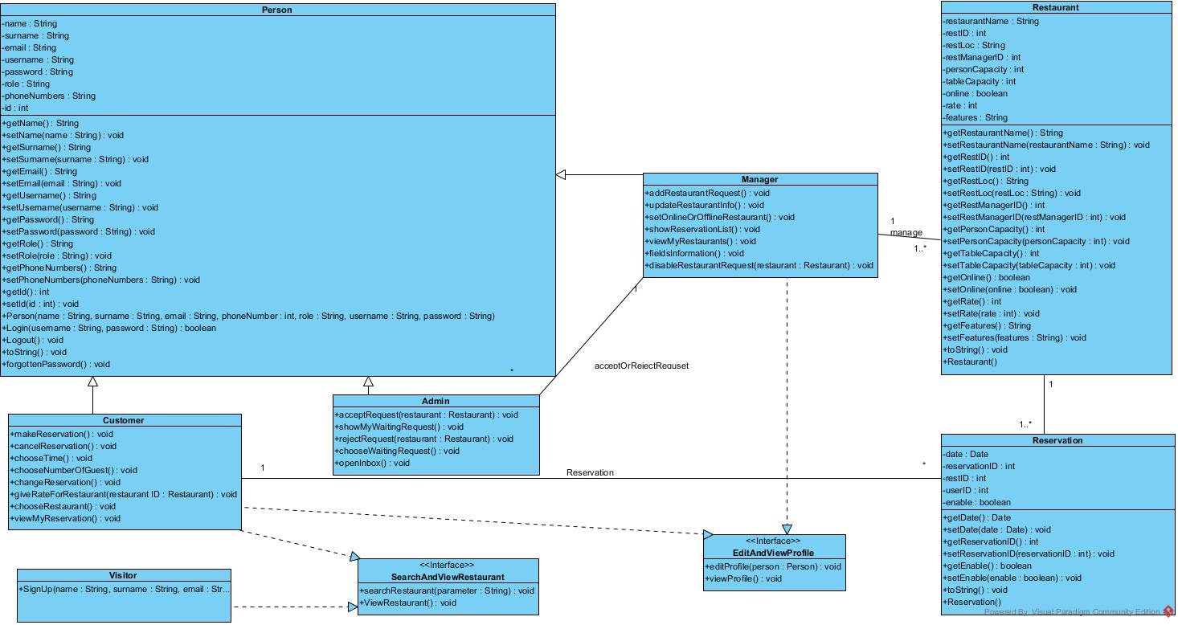

#### 

#### *Dynamic model*

Add Restaurant (ADMIN)

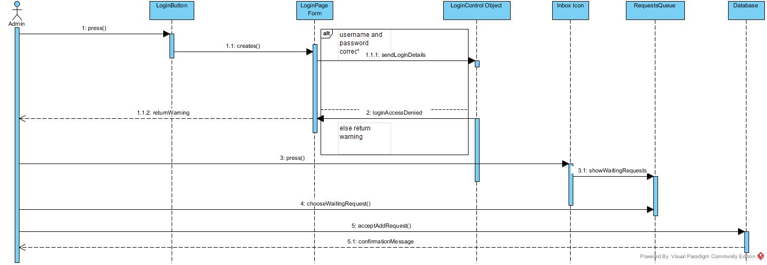

Disable Restaurant(ADMIN)

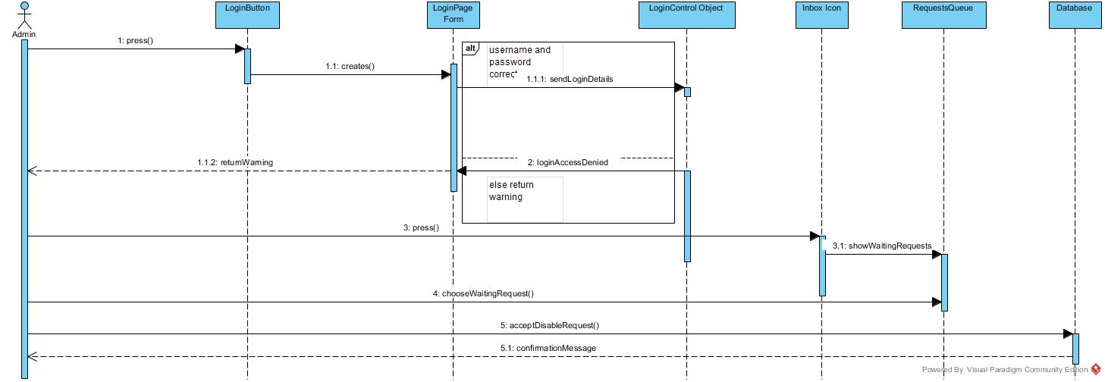

Send Add Restaurant Request(Manager)

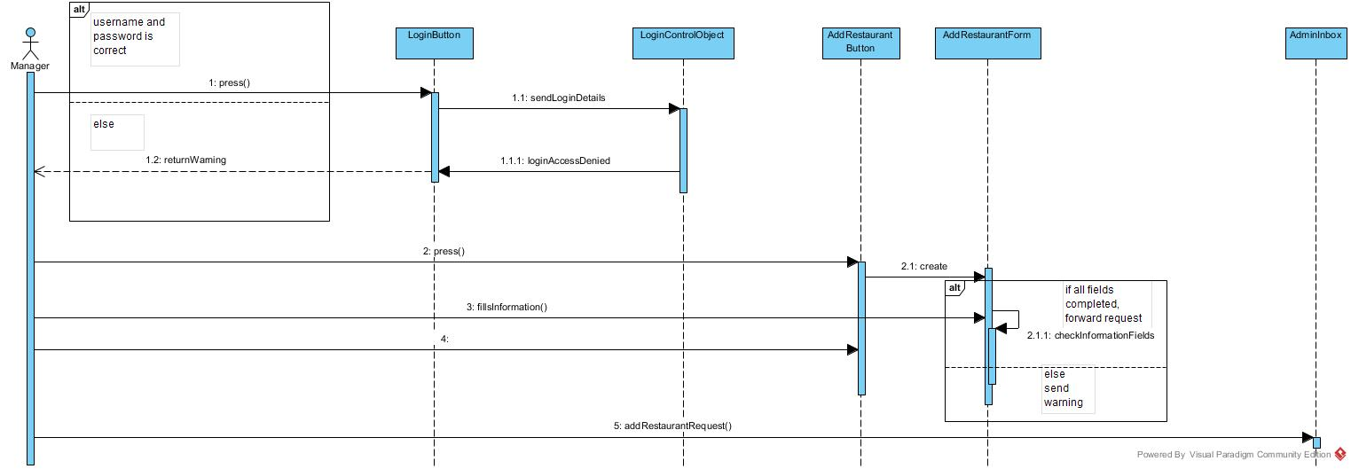

Send Disable Restaurant Request(Manager)

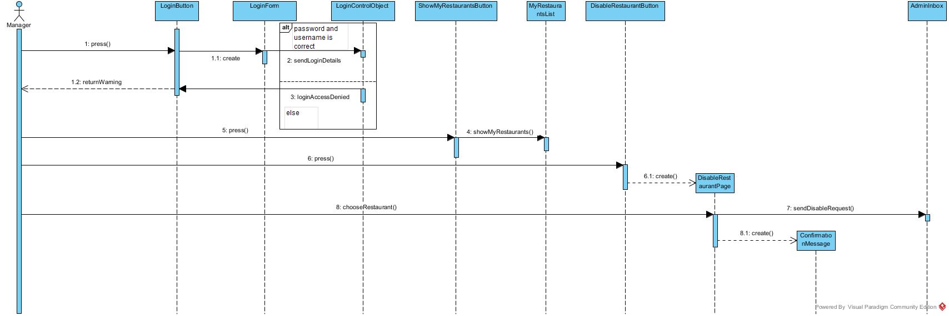

Make Reservation

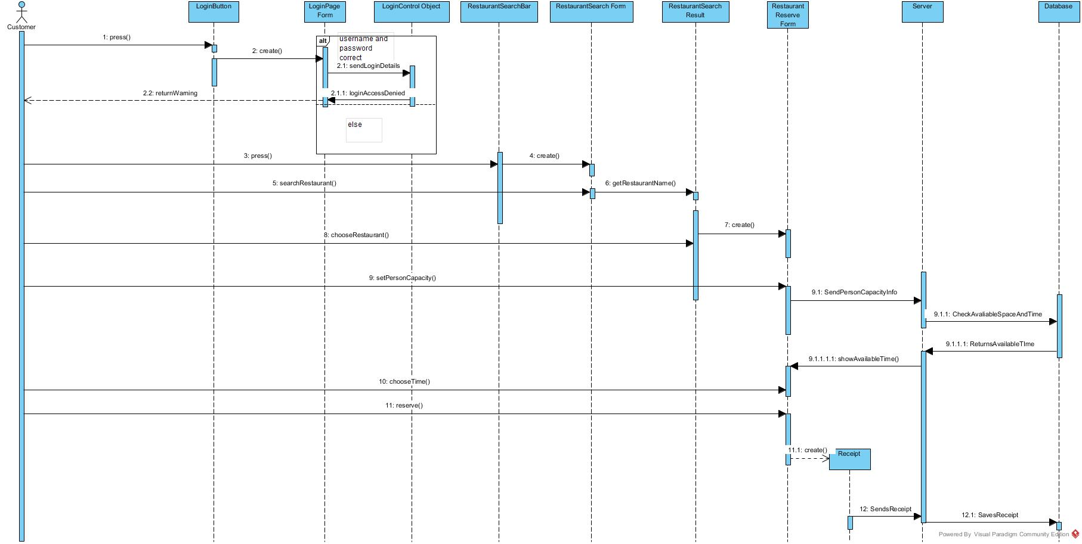

#### *User interface—navigational paths and screen mock-ups*

### 

### 3.5.Project Schedule

|  |  |  |  |  |
| --- | --- | --- | --- | --- |
| TaskName | StartDate | EndDate | Duration | Resources Names |
| 1.Introduction Of RAD | 18.10.2018 | 20.10.2018 | 2 | Abdul |
| 2.Current System Analysis | 15.10.2018 | 22.10.2018 | 7 | Alper, Burak, Abdul, Mert |
| 3.Proposed System |  |  |  |  |
| 3.1.Functional Requirements | 21.10.2018 | 24.10.2018 | 3 | Alper, Burak, Abdul, Mert |
| 3.2.NonFunctional Requirements | 22.10.2018 | 25.10.2018 | 3 | Alper, Burak, Abdul, Mert |
| 3.3System Models |  |  |  |  |
| 3.3.1.Scenarios | 12.10.2018 | 23.10.2018 | 11 | Alper, Burak, Abdul, Mert |
| 3.3.2.Use Case Model | 27.10.2018 | 30.10.2018 | 3 | Alper, Burak |
| 3.3.3.Object Model | 31.10.2018 | 2.11.2018 | 2 | Burak, Abdul |
| 3.3.4Dynamic Model | 3.11.2018 | 4.11.2018 | 1 | Abdul, Alper |
| 3.3.5.Mock-Ups | 26.10.2018 | 5.11.2018 | 10 | Mert |
| 4.Glossary | 4.11.2018 | 5.11.2018 | 1 | Mert, Abdul |

# 4. Glossary

To establish a clear terminology, developers **identify the participating objects** for each use case. Developers should **identify, name, and describe them** unambiguously and collate them into a glossary.

# 5. References

This subsection should:

* Provide a complete list of all documents referenced elsewhere in the RAD, or in a separate, specified document.
* Identify each document by title, report number - if applicable - date, and publishing organization.
* Specify the sources from which the references can be obtained.

The following is an example of listing a book in this section. Check the text to see how it is cross referenced (The whole document is based on [1]).

1. Bruegge B. & Dutoit A.H.. (2010). *Object-Oriented Software Engineering Using UML, Patterns, and Java*, Prentice Hall, 3rd ed.

**2.**